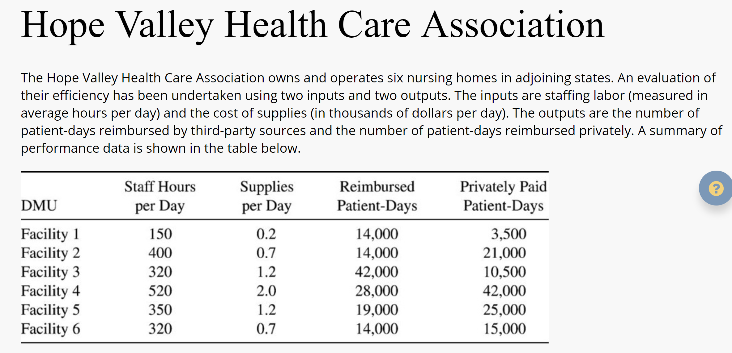

Do the following:

1. Perform DEA analysis by under all DEA assumptions of FDH, CRS, VRS, IRS, DRS,  and FRH.
2. Determine the Peers and Lambdas under each of the above assumptions
3. Summarize your results in a tabular format.
4. If possible, plot the frontier function for each part